ANOVA Analysis of Supply Chain Efficiency and Product Quality
STAT 301 Group Project | Supply Chain Dataset | n = 100 observations

1. Introduction
This project applies Analysis of Variance (ANOVA) methods to a supply chain dataset containing 100 observations and 24 variables. The dataset covers product types, suppliers, transportation logistics, manufacturing metrics, and quality outcomes across multiple locations in India. Two research questions are examined:
- Question 1 (One-Way ANOVA): Does product type significantly affect manufacturing costs?
- Question 2 (Two-Way ANOVA): Do transportation mode and product type interact to affect defect rates?
These questions explore cost efficiency (Q1) and product quality (Q2). Together they reveal whether product type matters on its own, and whether it interacts with logistics decisions to produce quality differences.
Variables used in this analysis:
- Product Type (categorical, 3 levels: cosmetics, haircare, skincare) — identifies product category.
- Manufacturing Costs (numeric, continuous) — total production cost per SKU in dollars. Response for Q1.
- Transportation Mode (categorical, 4 levels: Air, Rail, Road, Sea) — shipping method.
- Defect Rates (numeric, continuous) — proportion of defective units per SKU. Response for Q2.

2. Methods

2.1 Data Cleaning
The dataset was imported into R and cleaned prior to analysis. Ambiguous column names were renamed (e.g., two lead-time columns were renamed Supplier_Lead_Time and Order_Lead_Time). No missing values or duplicate rows were identified. Categorical variables were converted to factors and outlier detection via the IQR method found no extreme values. All 100 observations and 24 variables were retained.

2.2 Statistical Approach
For Q1, a one-way ANOVA was applied with Product Type (3 levels) as the factor and Manufacturing Costs as the response. The design is unbalanced (cosmetics n=26, haircare n=34, skincare n=40), but one-way ANOVA is robust to unequal group sizes. Tukey HSD post-hoc tests were conducted to assess pairwise differences.
For Q2, a two-way ANOVA with interaction was applied using Transportation Mode and Product Type as factors and Defect Rates as the response. Because the 4×3 design is unbalanced (cell sizes range from 4 to 13, see Table 1), Type II sums of squares were used via lm() and Anova() from the car package, which tests each effect after accounting for all others and is order-independent. Assumptions were checked using the Shapiro-Wilk test (normality) and Levene's test (homogeneity of variance).

3. Results

3.1 Q1: One-Way ANOVA — Product Type vs. Manufacturing Costs
H₀: Mean manufacturing costs are equal across all product types.
H₁: At least one product type has a different mean manufacturing cost.
Assumption checks passed: Shapiro-Wilk p = 0.112 (normality satisfied); Levene's test p = 0.384 (equal variances). ANOVA results are in Table 2.
Table 2: One-Way ANOVA — Manufacturing Costs by Product Type
Source | df | Sum Sq | Mean Sq | F value | p-value
Product Type | 2 | 629.0 | 314.6 | 0.370 | 0.692
Residuals | 97 | 82531.0 | 850.8 | — | —
Note: Significance level α = 0.05
Since p = 0.692 > 0.05, we fail to reject H₀. There is no statistically significant difference in mean manufacturing costs across product types. Tukey HSD post-hoc tests confirmed no significant pairwise differences (all adjusted p > 0.69). Group means were similar: cosmetics $43.05, haircare $48.46, skincare $48.99, as shown in Figure 1.
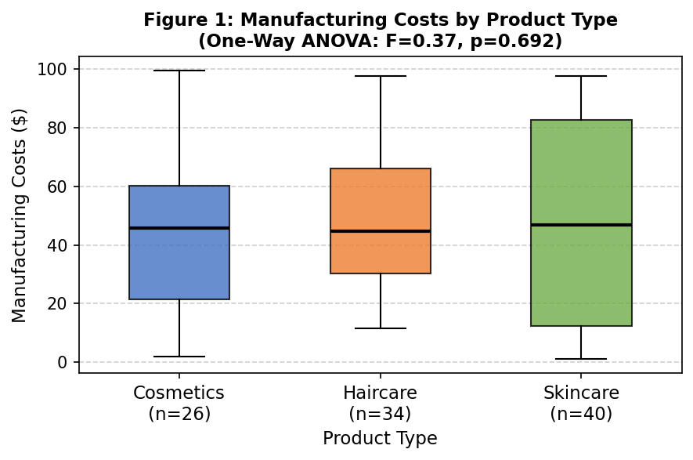
Figure 1: Manufacturing Costs by Product Type. Overlapping distributions and similar medians are consistent with the non-significant ANOVA result (F = 0.37, p = 0.692).

3.2 Q2: Two-Way ANOVA — Transportation Mode × Product Type vs. Defect Rates
H₀ (main effect, Transportation Mode): Mean defect rates are equal across all transportation modes.
H₀ (main effect, Product Type): Mean defect rates are equal across all product types.
H₀ (interaction): There is no interaction between transportation mode and product type on defect rates.
Table 1 documents the unbalanced cell counts across the design, justifying the use of Type II SS.
Table 1: Cell Counts — Transportation Mode × Product Type (Unbalanced Design)
Transport Mode | Cosmetics | Haircare | Skincare | Total
Air | 5 | 8 | 13 | 26
Rail | 9 | 10 | 9 | 28
Road | 6 | 12 | 11 | 29
Sea | 6 | 4 | 7 | 17
Total | 26 | 34 | 40 | 100
Note: Cell sizes range from 4 to 13, confirming the unbalanced structure.
Assumption checks: Shapiro-Wilk p = 0.068 (normality satisfied); Levene's test p = 0.340 (equal variances). The Q-Q plot in Figure 2 shows residuals closely following the theoretical normal line, providing additional visual confirmation.
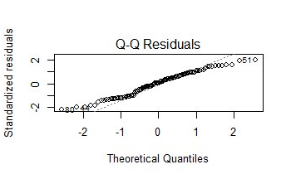
Figure 2: Q-Q plot of model residuals (Q2). Points follow the diagonal closely, confirming the normality assumption is satisfied.
Type II ANOVA results are shown in Table 3.
Table 3: Two-Way ANOVA (Type II SS) — Defect Rates by Transportation Mode and Product Type
Source | df | Sum Sq | F value | p-value | Significance
Transportation Mode | 3 | 7.68 | 1.35 | 0.263 | ns
Product Type | 2 | 2.37 | 0.62 | 0.539 | ns
Mode × Type (Interaction) | 6 | 21.99 | 3.05 | 0.014 | * (sig.)
Residuals | 88 | 105.22 | — | — | —
Note: ns = not significant; * = significant at α = 0.05
Neither transportation mode (p = 0.263) nor product type (p = 0.539) had a significant main effect on defect rates. However, their interaction was statistically significant (p = 0.014). When an interaction is present, the main effects cannot be interpreted in isolation — the effect of transportation mode on defect rates depends on which product type is shipped. Post-hoc Tukey comparisons within each mode revealed:
- Air: Cosmetics had significantly lower defect rates than haircare (estimate = −2.53, adjusted p = 0.005) — the primary driver of the interaction.
- Rail: No significant pairwise differences between product types (all p > 0.30).
- Road: No significant pairwise differences between product types (all p > 0.30).
- Sea: No significant differences, though haircare vs. skincare approached significance (p = 0.085).
Figure 3 illustrates the interaction. The lines are clearly non-parallel under Air — cosmetics starts very low (~0.4) while haircare starts high (~3.0) — confirming the interaction is driven primarily by behavior under air transportation. Lines converge and run roughly parallel under Rail, Road, and Sea.
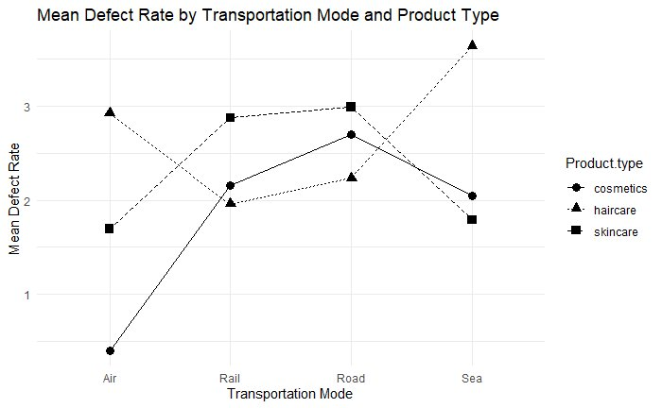
Figure 3: Interaction plot of mean defect rates by Transportation Mode and Product Type (ggplot2). The divergence of cosmetics (circle) and haircare (triangle) lines under Air confirms the significant interaction (p = 0.014). No meaningful separation is visible under Rail or Road.

4. Conclusion
This analysis applied one-way and two-way ANOVA to a supply chain dataset to examine cost efficiency and product quality.
For Q1, no evidence was found that product type affects manufacturing costs (F = 0.37, p = 0.692). The three product types incur similar production costs, suggesting manufacturing expenses are driven by other factors not captured in this dataset.
For Q2, no significant main effects were found for transportation mode or product type individually, but a significant interaction was detected (p = 0.014). Defect rates depend on the combination of transportation mode and product type. Specifically, haircare products experience significantly higher defect rates than cosmetics when transported by air, while no meaningful differences exist under rail, road, or sea modes. This has a direct managerial implication: air transport should be used cautiously for haircare products, and routing decisions should account for product-specific sensitivity rather than applying uniform policies.
Together, the two questions tell a coherent story: product type alone does not drive costs or defect rates, but its interaction with logistics decisions reveals meaningful quality differences — underscoring the importance of examining combined operational factors.

Limitations
- Sample size: With n = 100 across 12 cells, some cells have as few as 4 observations, reducing statistical power.
- Observational data: No causal conclusions can be drawn. Unobserved confounders (e.g., distance, packaging) may explain the interaction.
- Generalizability: Results reflect one supply chain context and may not transfer to other industries or regions.

